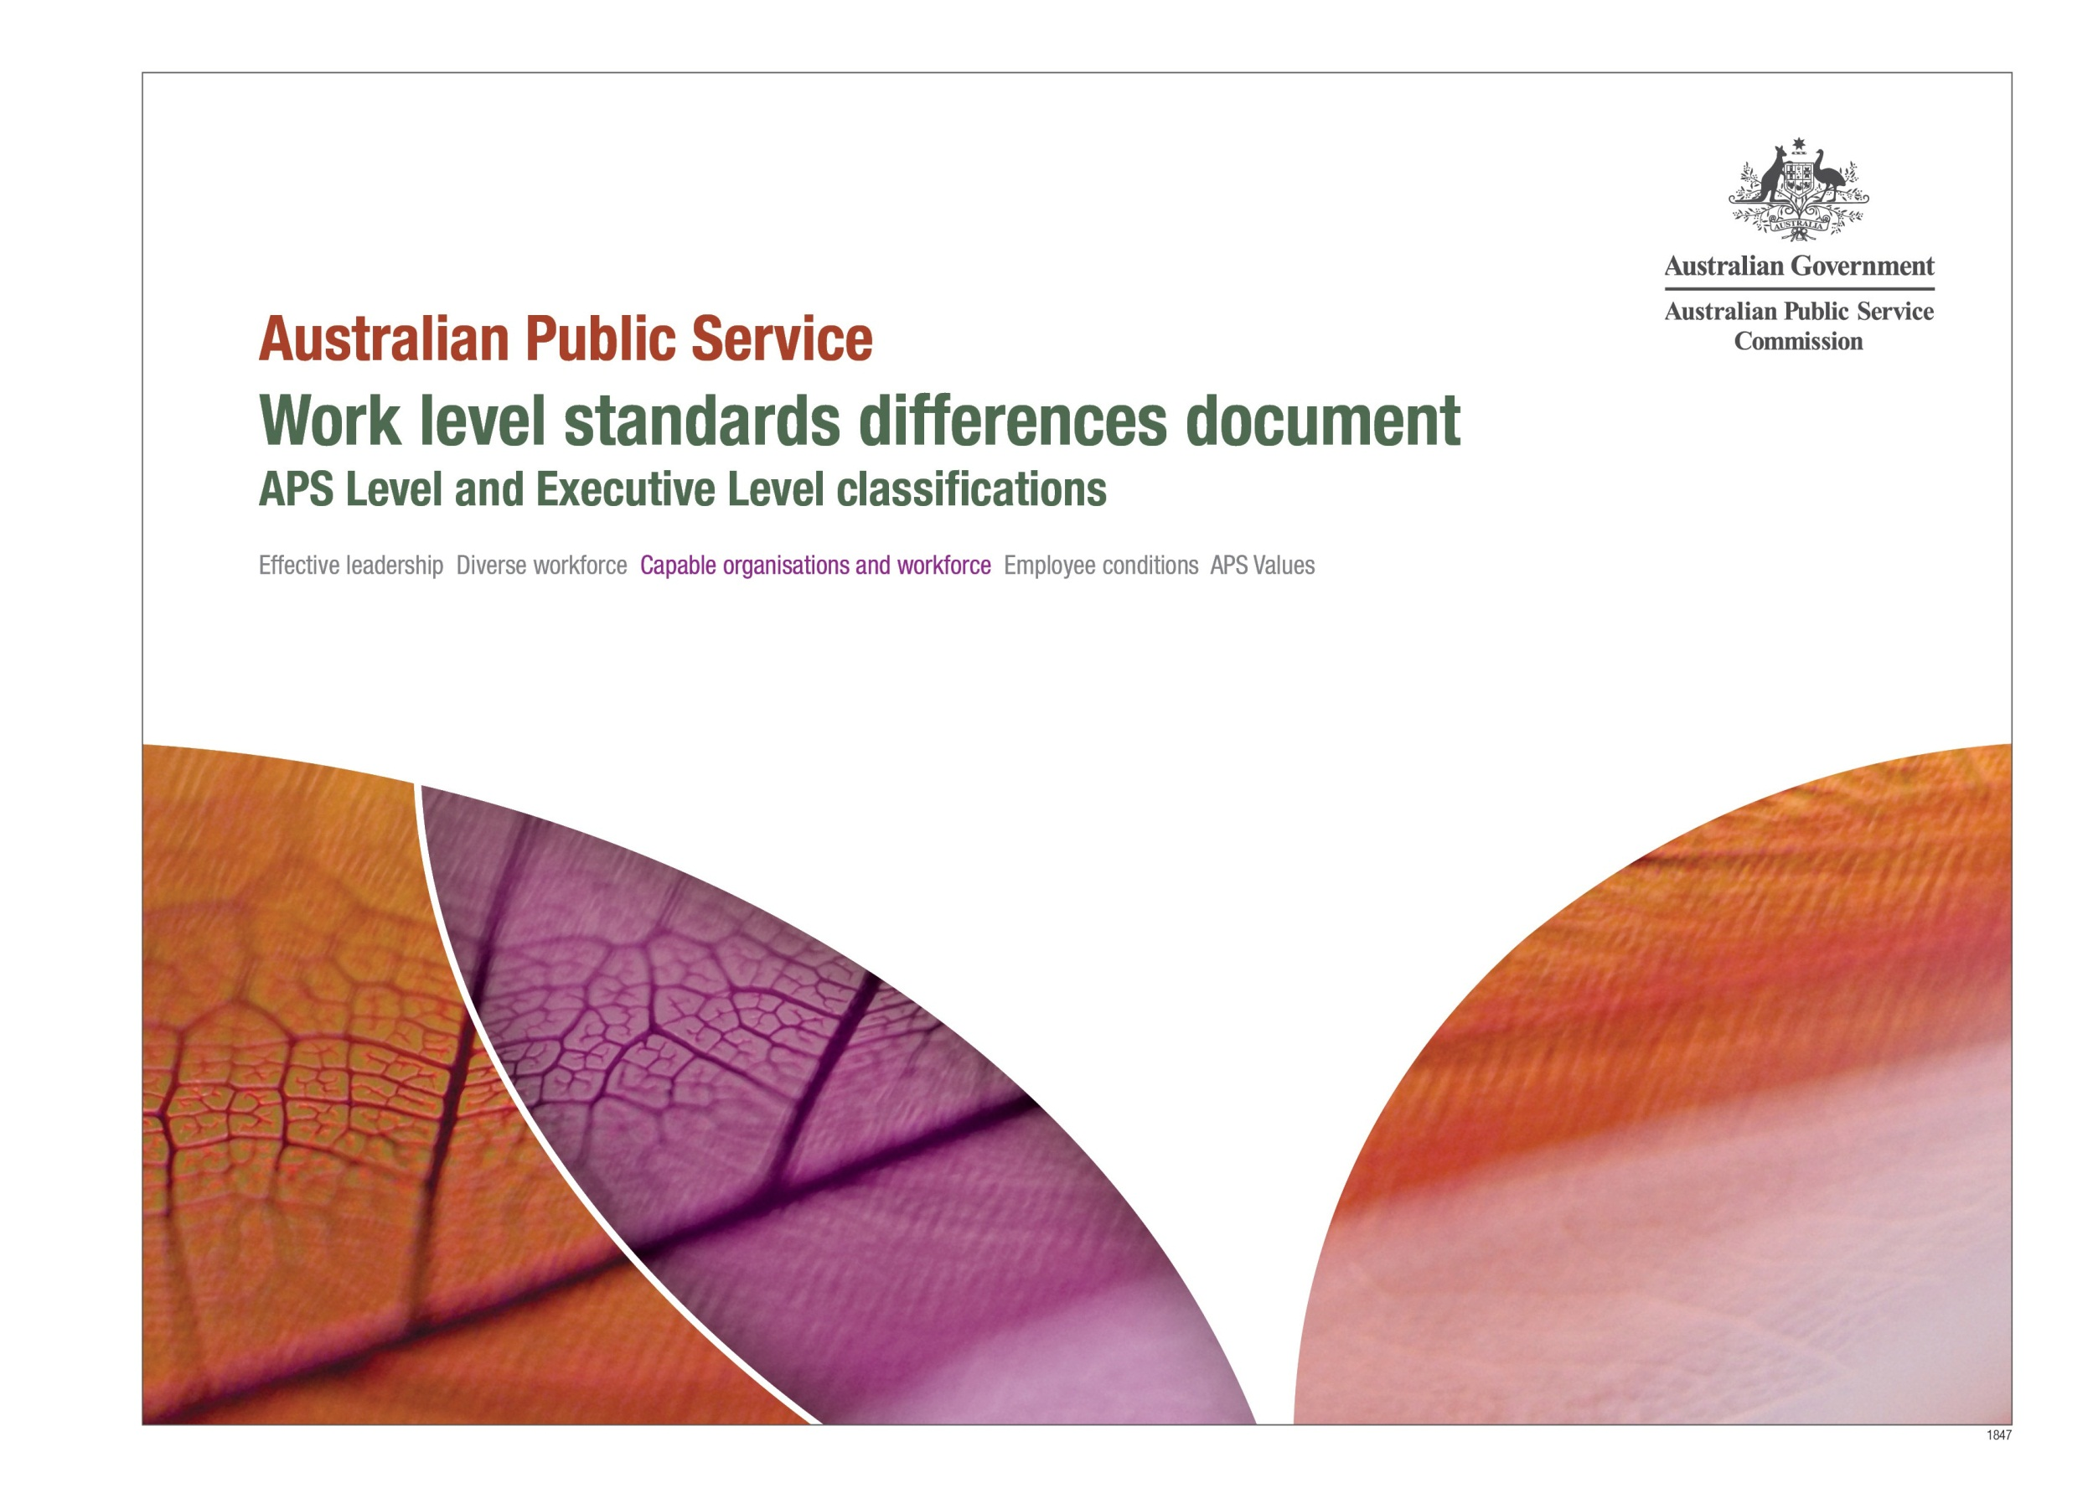

© Commonwealth of Australia 2013
All material produced by the Australian Public Service Commission (the Commission) constitutes Commonwealth copyright administered by the Commission. The Commission reserves the right to set out the terms and conditions for the use of such material.
Apart from any use as permitted under the Copyright Act 1968 and those explicitly granted below, all other rights are reserved.
Unless otherwise noted, all material in this publication, except the Commission logo or badge, the Commonwealth Coat of Arms, and any material protected by a trade mark, is licensed under a Creative Commons BY Attribution 3.0 Australia licence.
Details of the licence are available at <http://creativecommons.org/licenses/by/3.0/au/>.
Attributing Commission works
Use of Commission material licensed under a Creative Commons BY Attribution 3.0 Australia licence requires you to attribute the work in the manner specified by the Commission (but not in any way that suggests that the Commission endorses you or your use of the work). Almost any form of words is fine provided that you:
- provide a reference to the publication and, where practical, the relevant pages
- make clear whether or not you have changed Commission content
- make clear what permission you are relying on, by including a reference to this page or to a human-readable summary of the Creative Commons BY Attribution 3.0 Australia licence
- do not suggest that the Commission endorses you or your use of our content.
For example, if you have not changed Commission content in any way, you might state: ‘Sourced from the Australian Public Service Commission publication APS work level standards differences document APS and EL classifications. This material is licensed for reuse under a Creative Commons BY Attribution 3.0 Australia licence.’
If you have made changes to Commission content, it would be more accurate to describe it as ‘based on Australian Public Service Commission content’ instead of ‘sourced from the Australian Public Service Commission’.
Enquiries
For enquiries concerning reproduction and rights in Commission products and services, please contact communicationsunit@apsc.gov.au.

Australian Public Service Work Level Standards – Differences Document
Purpose
This document summarises some of the key responsibilities and requirements that differentiates each classification level from the others. For each classification level, the list describes role characteristics that are introduced at that level or that increase in complexity relative to the classification level below. The document is not an exhaustive list of job tasks, rather, it focuses on those activities that differentiate job levels. A full description of expectations at each classification level can be found in the Work Level Standards.

 | APS 1 | APS 2 | APS 3 | APS 4 | APS 5 | APS 6 | EL 1 | EL 2
Knowledge |  |  | Functional expertise that contributes to team goals | Functional expertise in a specific area that contributes to team goals | Technical expertise that contributes to business unit outcomes | Expertise and technical knowledge in a specialist area | Expertise across a broad range of activities potentially relating to the work of different program areas | Strategic level of specialist, professional and/or technical expertise potentially relating to the work of different program or discipline areas
Advice | Provide procedural advice and respond to straightforward requests for information | Provide advice on procedural and technical issues relating to immediate work area | Provide advice using established policy and procedures as a guide | Provide sound advice which influences decisions by others | Provide professional and policy advice within an area of specialisation | Provide accurate specialist advice | Provide expert advice internally and externally to the organisation | Provide advice that influences strategic direction
Results | Complete allocated tasks, within required timeframes and compliant with set procedures |  | Set priorities, complete allocated tasks, make decisions within defined parameters relating to the area of responsibility | Complete allocated tasks, monitor work flow and review work of less experienced employees | Accountable for tasks and decisions. Support less experienced employees to achieve goals by providing guidance and quality assurance | Set priorities and ensure quality of outputs for the work area | Responsible for the achievement of own and team outcomes, monitor team progress and follow through to deliver quality outcomes | Anticipate and establish priorities, monitor progress and work to deliver agency functions or a program within an area of responsibility
Planning | Plan for the achievement of own results | Contribute ideas to the development of work area goals and objectives | Responsible for planning own work goals and priorities that align with and achieve own and team outcomes | Participate in strategic planning and decision making within the work area | Develop objectives for short-term tasks and participate in strategic planning for longer-term initiatives | Develop objectives for short-term tasks and contribute to strategic planning for longer-term initiatives | Determine strategic direction for the work area and align longer-term planning with agency goals and objectives | Contribute to agency wide strategic planning. Set strategic direction, develop long-term plans and implement strategies for work area

 | APS 1 | APS 2 | APS 3 | APS 4 | APS 5 | APS 6 | EL 1 | EL 2
Innovation, Change & Business Improvement | Participate in the implementation of change and contribute to the improvement of quality and efficiency of services and work processes | Contribute ideas and participate in the implementation of change in the workplace | Contribute to the improvement of quality and efficiency of services | Contribute new ideas and identify opportunities to improve the efficiency of business processes | Apply innovative initiatives and contribute to change and to the improvement in quality and efficiency of services | Propose and facilitate innovation initiatives and contribute to business improvement strategies and change in the workplace | Generate new ideas approaches and strategies. Implement change and business improvement strategies in the workplace | Identify and lead innovation solutions. Provide leadership in implementing and promoting change and continuous improvement in the workplace
Risk Management | Identify and manage risks that affect  day-to-day tasks |  | Perform risk analysis activities and develop compliance strategies | Identify and mitigate risks which impact of own and team outcomes | Assist with maintaining risk management programs | Perform quality assurance of risks and treatments for area of responsibility | Undertake risk management and assessment activities for area of responsibility | Identify and manage risk in all areas of decision-making
Complexity | Required to undertake basic and routine tasks | Required to undertake straightforward tasks | Required to undertake straightforward tasks. Some tasks may have an element of complexity | Required to undertake tasks of moderate complexity | Required to undertake work that is moderately complex to complex in nature | Required to undertake work that is complex in nature | Required to undertake work that is very complex or sensitive | Required to undertake work with a high level of complexity or sensitivity
Legislation | Have basic understanding of relevant legislation and policy frameworks |  | Understand relevant legislation and policy frameworks | Have a good understanding of relevant legislation and policy frameworks | Maintain a well-developed understanding of relevant legislation and policy frameworks | Have an in-depth understanding of and compliance with relevant legislation and policy frameworks | Have an extensive understanding and compliance with relevant legislation and policy frameworks | Have an excellent understanding and articulate legislative, financial and administrative frameworks and government decision-making
Guidance | Works under close supervision and direction against clearly defined and established priorities and procedures | Works under direct guidance against established priorities and procedures | Works under general supervision and direction against established priorities and procedures. Exercise some autonomy about how work tasks are performed | Works under general direction. Exercises some discretion with respect to how procedures and guidelines and interpreted and applied | Works under limited direction and makes independent decisions relating to an area of responsibility | Works under limited direction with opportunity for autonomy and accountability in interpreting policy and the application of practices and procedures | Operates under broad direction exercising a considerable degree of independence | Operates under broad direction and exercises a significant degree of independence
Decisions | Make decisions that are based on defined outcomes, priorities and performance standards | Make decisions of a procedural or administrative nature | Make decisions within defined parameters and following established procedures and protocols | Make decisions within defined parameters relating to the area of responsibility | Make decisions within defined parameters and sets new precedents based on sound subject matter knowledge and professional judgement | Make decisions using good judgement, expertise and knowledge. Is governed by the application of regulations, best practice principles or the agency’s operating instructions and procedures | Make decisions that are based on professional judgement, evaluating risks and in the context of a complex and changing environment | Make balanced decisions using professional judgement, evaluating ambiguous and incomplete information, factoring in risks and being sensitive to the context
Impact of decisions made | Decisions generally have a minor impact on own work area | Decisions have a low impact on the work area or specific function | Decisions are likely to impact the work area or specific function | Decisions impact on the work area or specific function | Decisions may impact on the overall outcomes for the work area | Decisions have a medium to high level of impact on the work area; however, the impact on agency operations and resources is usually limited | Decisions have a high level of impact on the functional area and the potential to impact more broadly on agency operations and externally | Decisions may have significant impact on the day-to-day operation of the work area and other parts of the agency; and/or a direct and significant impact on the outcome of a program or major project for the agency
Research | Roles may play an administrative support role to other employees involved in research and investigative work | Roles may undertake preliminary work for research tasks in a specific area of knowledge or specialisation | Roles may undertake some research and analysis activities | Roles may conduct research and analysis activities and report on findings | Perform objective and systematic research and analysis to obtain accurate conclusions based on evidence | Perform research and analysis to make decisions that involve complex or escalated issues, longer-term planning and liaison with other sections on policy, project or operational issues | Work with a focus on research, analysis and judgement to manage complex issues | Undertake complex analysis and interpretation and apply significant judgement in choosing a course of action to manage highly complex and/or sensitive issues
Stakeholder relationships | Support effective stakeholder relationships. Liaise with stakeholders and respond to routine matters | Support and maintain effective stakeholder relationships. Liaise and respond to routine enquiries or straightforward matters | Cultivate effective stakeholder relationships. Liaise with stakeholders and assist to resolve straightforward matters | Build rapport and maintain stakeholder relationships. Liaise with stakeholders and assist to resolve moderately complex issues | Develop and maintain internal and external relationships. Liaise with stakeholders on policy, project or operational issues responding to stakeholder needs and expectations | Develop and support complex relationships with internal and external stakeholders. Manage relationships with stakeholders to achieve work area and agency goals. Anticipate and respond to stakeholder needs and expectations | Develop and manage a range of stakeholder relationships. Engage and collaborate with key stakeholders to identify opportunities, achieve outcomes and facilitate cooperation | Develop and manage key strategic relationships with a broad range of stakeholders, promoting the agency’s business objectives and communicating the strategic direction and vision of the agency
Represent the agency |  |  | Represent the work area at internal meetings | Represent the work area at internal and external meeting and conferences | Represent the work area or agency at meeting, conferences or seminars | Represent the agency by promoting its interests at community and cross-agency levels | Represent and explain the views of the agency at cross-agency meetings and other forums | Represent and negotiate on behalf of the agency to advance the agency’s interests in cross-agency, inter-jurisdictional, international and other forums
Supervision / Management | Roles have no supervisory function, although may assist others to become familiar with routine work practices and tasks | Roles have a minimal supervisory function but may provide on-the-job training to develop the skills of lower classification levels on routine work matters and practices | Roles may provide mentoring, on-the-job training, and provide advice and guidance on procedural matters to a team | Roles may be responsible for coaching and mentoring and identifying training needs for a team | Role may be responsible for identifying training needs for a team, and participating in performance management processes, including providing performance feedback | Roles may be responsible for the supervision and development of lower classification levels; building team capacity through coaching, performance feedback; and encouraging career development | Roles may be responsible for building capability in a team environment through coaching others, providing performance feedback, conflict resolution and encouraging career development | Role may be accountable for developing, coaching and mentoring employees, performance management, conflict resolution, and identification of training needs

